Assignment 2.3 AI ASSISTED CODING
HTNO:2303A51983
BTNO:06
TASK 1:
Prompt:
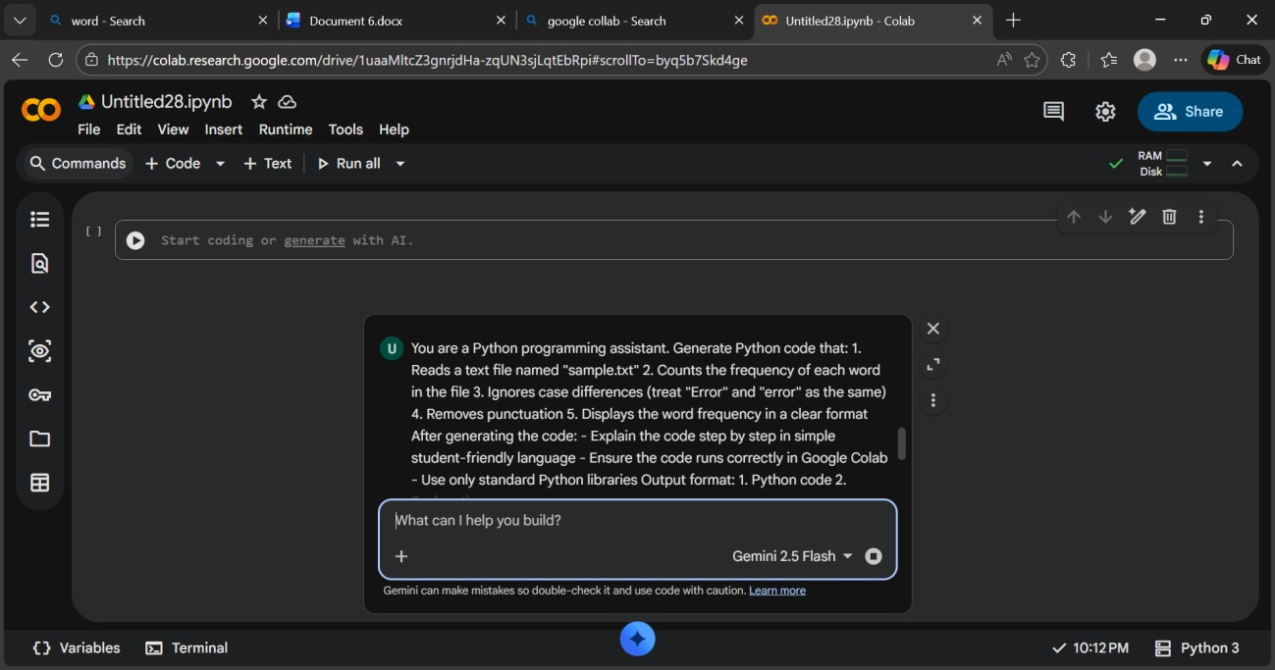
Code:
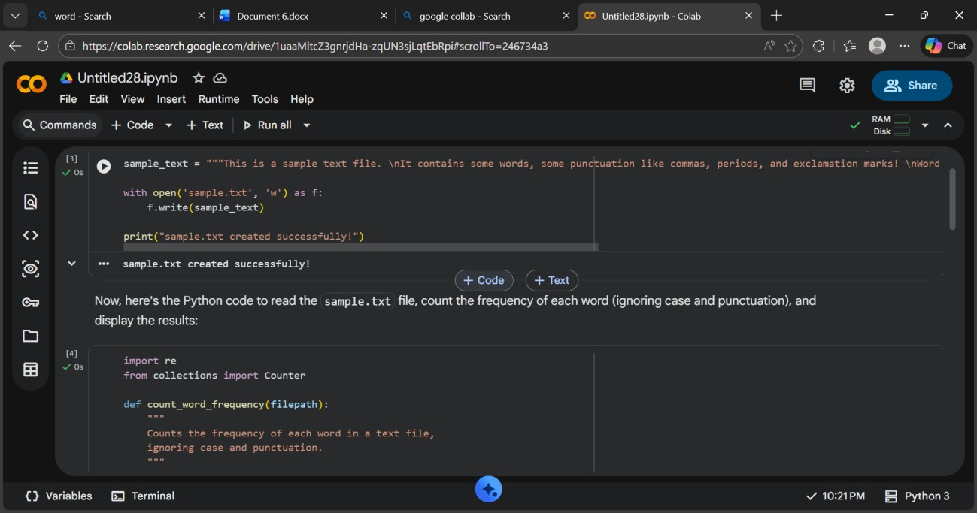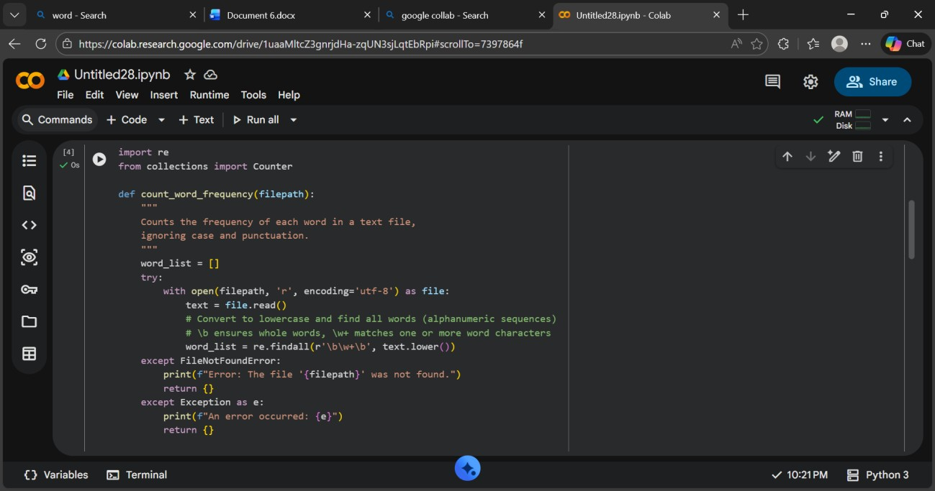
Output:
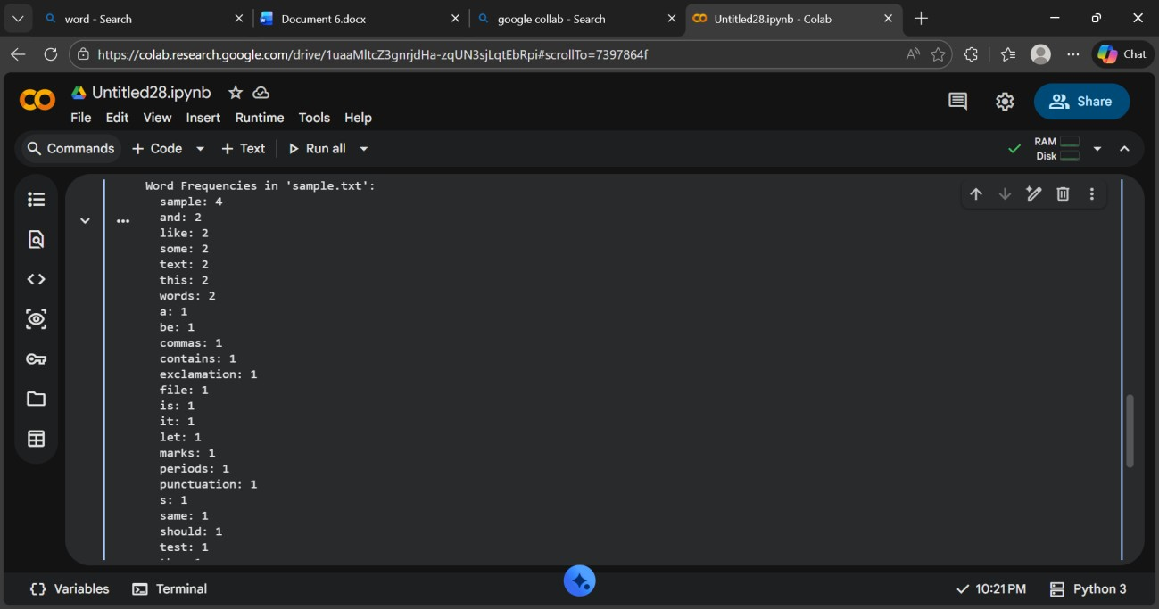
Explanation:
The program reads text from a file and converts all words to lowercase to avoid case differences.
It removes punctuation and splits the text into words, then counts how many times each word appears.
Finally, it prints each word along with its frequency in the file.
Task 2:
Prompt:
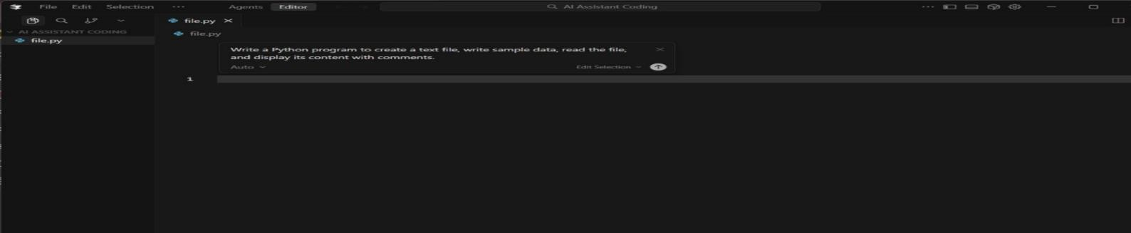
Code:
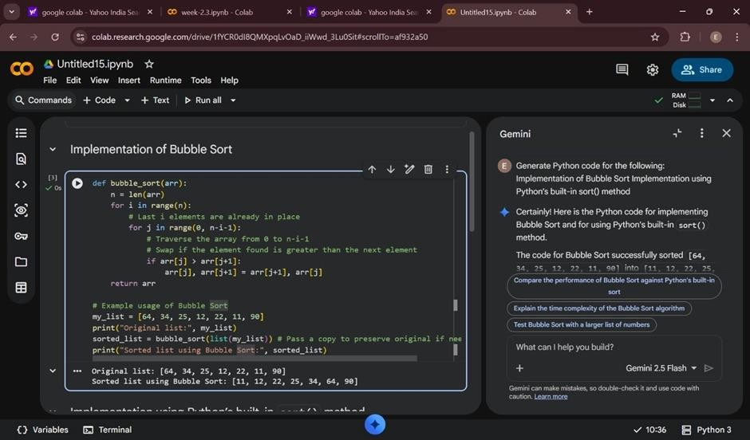
Output:
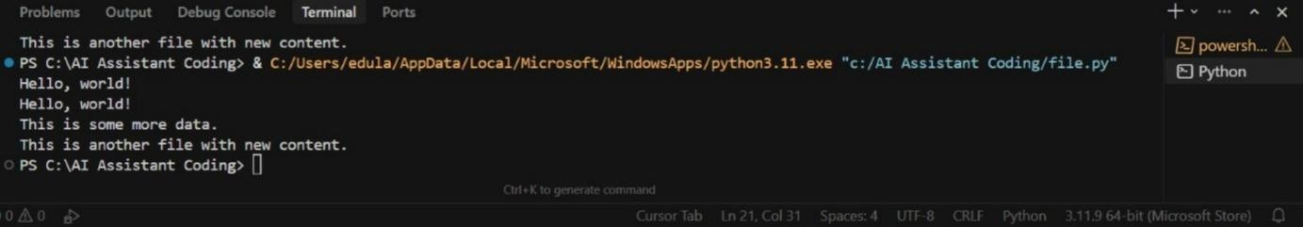
Explanation: The program creates a text file and writes sample text into it using file handling methods.
It then reads the file content and displays it on the screen.
Task 3: CSV Data Analysis Prompt:
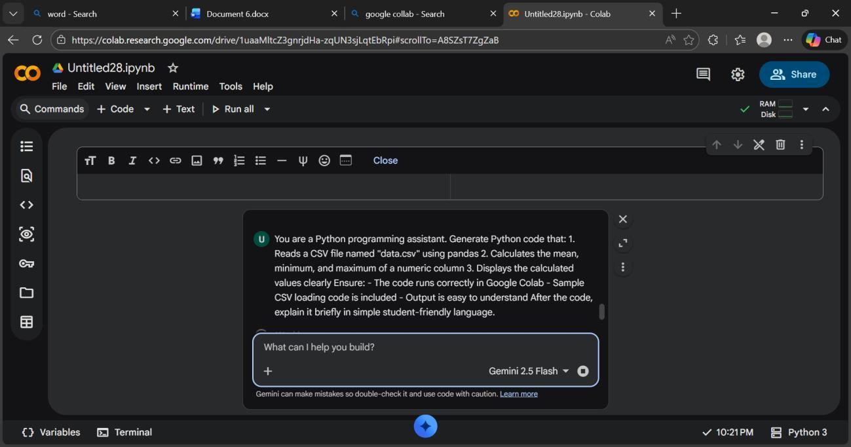
Code:

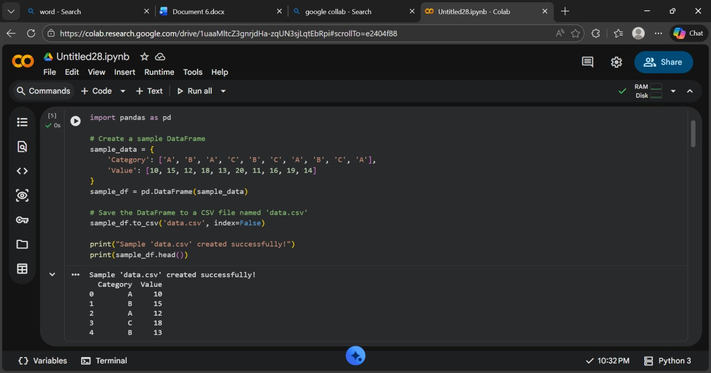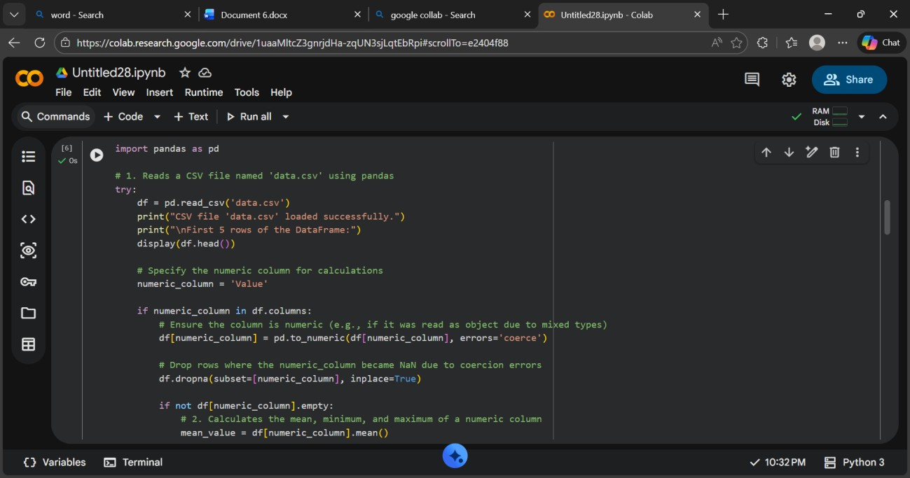

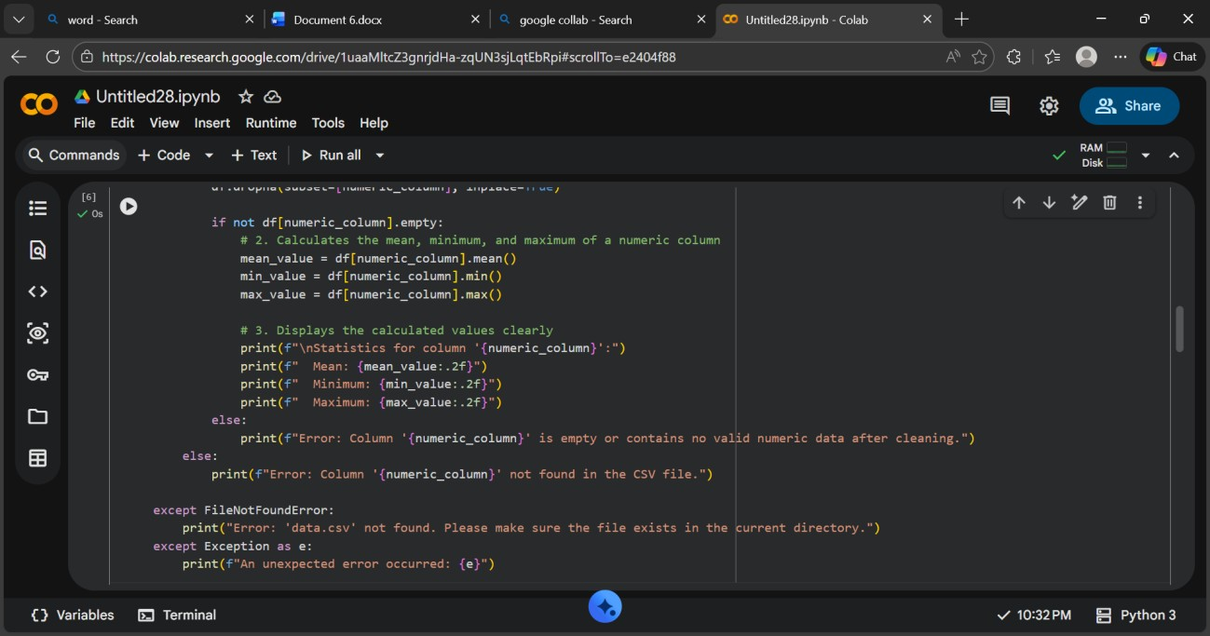
Output:
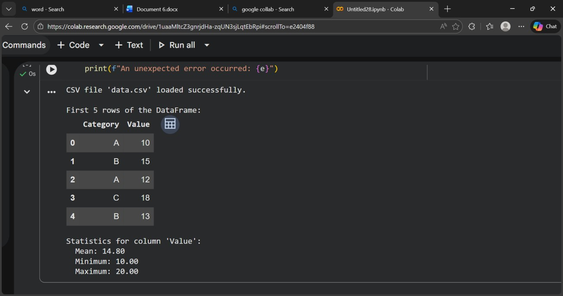
Explanation: Manual sorting uses loops and comparisons to arrange elements step by step.
Built-in sorting is faster and simpler as Python handles the sorting internally.
Task 4: Sorting Lists – Manual vs Built-in Prompt:
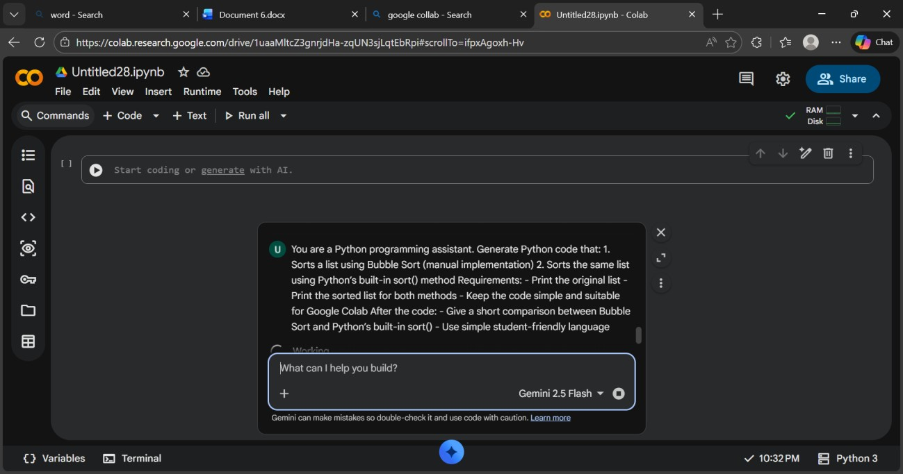
Code:
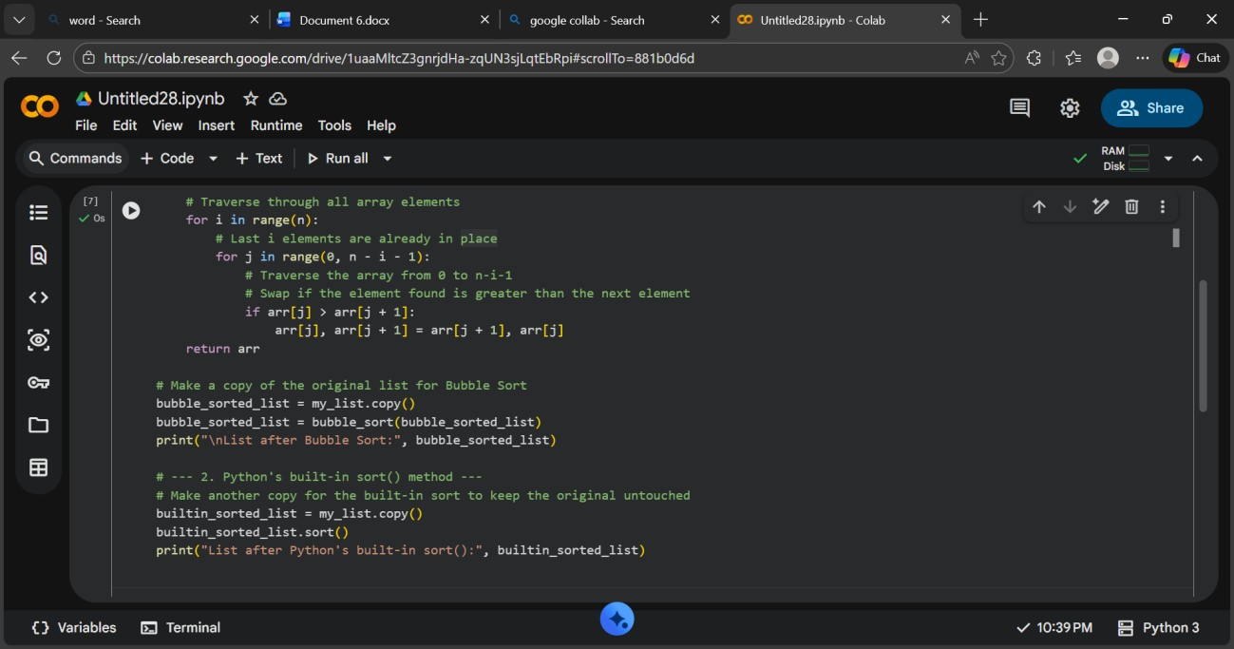
Output:
Expalantion: Bubble sort repeatedly compares and swaps elements and is slow for large lists.
Python’s built-in sort() is faster and more efficient because it uses optimized algorithms.
